Association for Women Geoscientists Southeastern Bluegrass Chapter Student Research Grant

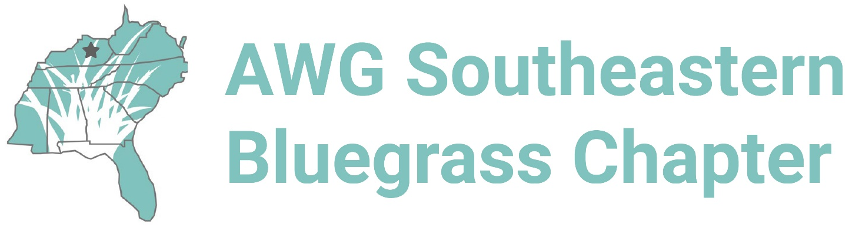

The Southeastern Bluegrass Chapter of the Association for Women Geoscientists is pleased to announce its annual student research grant solicitation for 2022. In partnership with the AWG Foundation, a scholarship in the amount of $500 will be awarded to two female students in geoscience to cover costs associated with research or travel to a scientific conference.
ELIGIBILITY
- Applicant must be a member of the Southeastern Bluegrass chapter of AWG.
- Applicant must identify as a woman (cis, trans, gender fluid, and non-binary welcomed).
- Applicant must be enrolled (undergraduate, M.S., or Ph.D. students) in an accredited college or university in Kentucky for at least one full semester before the award application.
- Applicant must be enrolled (undergraduate, M.S., or Ph.D. students) in an accredited college or university in Kentucky for one full academic year after the award application.
- Applicant must be pursuing a degree in a geoscience-related field (e.g., environmental science, geology, geophysics, GIS, hydrogeology, marine geology, mining engineering, paleoecology, paleoclimatology, paleoceanography, paleontology, physical geography, water resource management, etc.).
QUALIFYING EXPENSES: Any lab analyses and/or supplies, field work costs (e.g., airfare, accommodations, transportation, fees, field supplies, food), conference, meeting, and workshop costs (e.g., airfare, accommodations, transportation, fees, registration, food, printing), publication costs, and/or university fees.
HOW TO APPLY: Complete the following application form, including a one-page research merit statement that describes the purpose and importance of the applicant’s research and how this funding will help the applicant achieve their research and/or professional goals. Please also include an anticipated budget in the table provided. Email completed application to sebluegrassawg@gmail.com by 1 May 2022 at 23:59:00. Awardee will be contacted by 31 May 2022.
CRITERIA
- Completeness of application (includes CV, budget, research merit statement)
- Appropriateness to scholarship objective for the “AWG SEB Kentucky Geoscience Student Research Scholarship”
- Statement of Research Merit (quality, clarity, detail)
- Required attendance in AWG SEB for a year
AWG Southeastern Bluegrass Student Research Grant Application
Application materials must be submitted by 1 May 2022 at 23:59:00 to sebluegrassawg@gmail.com

Name:
University and department:

Current Program (undergraduate, M.S., or Ph.D.?):
Approximate start date in program:
Anticipated end date in program:
Research project title (if known):

University email address:
Phone number:
Address:

Please email AWG Southeastern Bluegrass officers with any questions at sebluegrassawg@gmail.com.
A one-page research merit statement and the applicant’s CV must accompany this application.
RESEARCH MERIT STATEMENT AND APPLICATION OF FUNDS: Please add one page to this document describing your research project and plans for this funding. Be sure to include your main research questions and the significance of this research to your field. If this funding will go to a subset of your main thesis or dissertation work, please explain its significance. Also describe how this grant will help you achieve your goals with respect to this research and your broader professional goals. (Use Arial or Times New Roman font, size 12 pt., single-spaced).
ANTICIPATED BUDGET: In the table below, please provide an anticipated budget for this grant. Support may go towards costs associated with fieldwork, lab work, conferences and/or workshops, publications, university fees, and other expenses at the discretion of the Award Committee. Although exact costs may not yet be known to the applicant, please include your best estimate. Add rows as needed.

Anticipated Student Research Grant Budget
Itemized Cost Description | Projected Price
Total Projected Costs

